Looking for Pythagoras

**Sample.**

**(Method 2)**

Step 1: Find the area of the rectangle.

Step 2: Subtract the area of the outer triangles.

Step 3: Answer

**Find the area. (Method 1)**

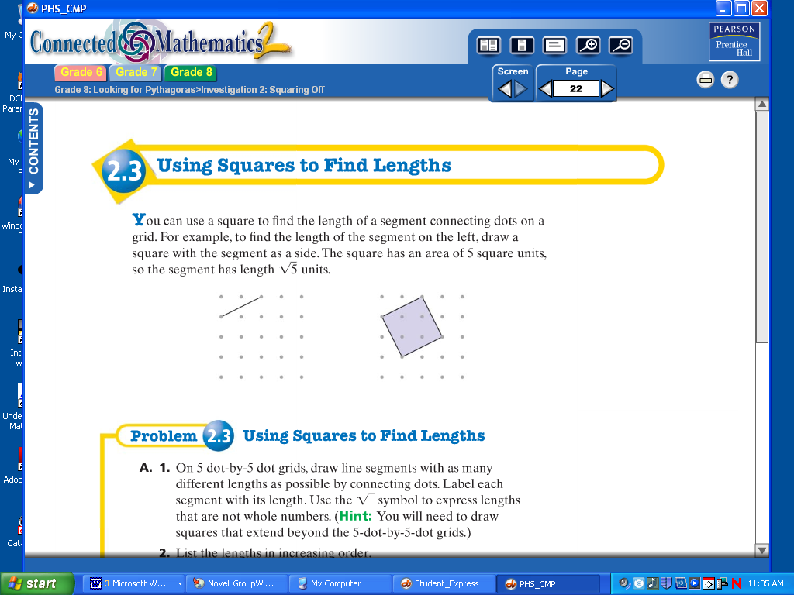

1

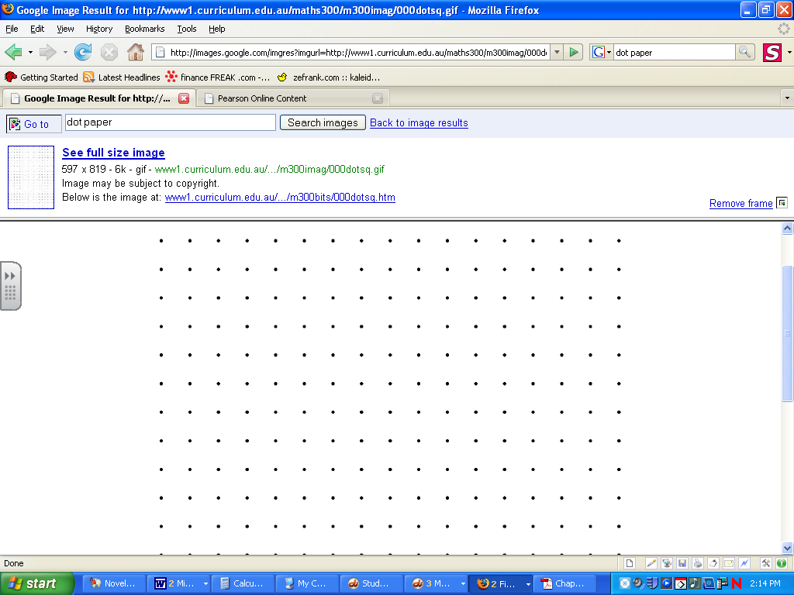

½(2)

3

½ (2)

Asquare = (3)(3) = 9 u2

A1 = ½(2)(1) = 1

A2 = ½(2)(1) = 1

A3 = ½(2)(1) = 1

A4 = ½(2)(1) = 1

Aall = A1 + A2 + A3 + A4 = 4 u2

AT = 9 – 4 = 5 u2

1

½ (2)

2



½(2)

As = 3(3) = 9 u2

A1 = ½(1)(2) = 1 u2

A2 = ½(3)(1) = 1.5 u2

A3 = ½(2)(3) = 3 u2

Aall = 1+1.5+3 = 5.5 u2

AT = 9 – 5.5 = **3.5 u2**

1

2

4

3

A = 1 + 1 + 1 + 1 + 1 = 5 u2

*Divide into smaller rectangles.*

**Estimating square roots.**

Ex. 

**Finding square roots.**

Ex. 1:  = 5 Ex. 4: 

Ex 2: −= −11 Ex. 5: 

Ex 3:  = 

Check:

9.6 9.7

x 9.6 x 9.7

92.16 94.09

81

100

9

10

9.5

90.5

** 9.6 or 9.7**

Step 1: Find the two perfect squares the number falls in between.

Step 2: Take the square root of those perfect squares.

Step 3: Find the middle number.

Step 4: Estimate the decimal value using the middle # to assist.

Step 5: Check the estimate.

x = 49

**Right triangle vocabulary.**

a

Leg

b

Leg

**Pythagorean Theorem.**

a2 + b2 = c2

*Use the drawing to the right to determine a, b, & c.*

Hypotenuse

c



**Finding the length of a missing side.**

Ex 1:

Ex 2:

**Proving right triangles.**

Ex. 9, 7, 11 a2 + b2 = c2

72 + 92 = 112

49 + 81 = 121

130 121

Not right triangle

Ex. 2, 5,  a2 + b2 = c2

22 + 52 =2

4 + 25 = 29

29 = 29

Right Triangle

a2 + b2 = c2

52 + x2 = 132

25 + x2 = 169

-25 -25



x = 12 cm

x

13 cm

?

?

5 cm

?

?

a2 + b2 = c2

32 + 72 = x2

9 + 49 = x2

 = 

7.62 cm ≈ x

3 cm

x

7 cm

**Finding the flying distance.**

Find the flying distance from the hospital to the animal shelter.

Step 1: Make a triangle.

Step 2: Count the horizontal and vertical distances.

Step 3: Use the Pythagorean Theorem to find the hypotenuse.

a2 + b2 = c2

22 + 122 = x2

4 + 144 = x2

 = 

12.17 ≈ x

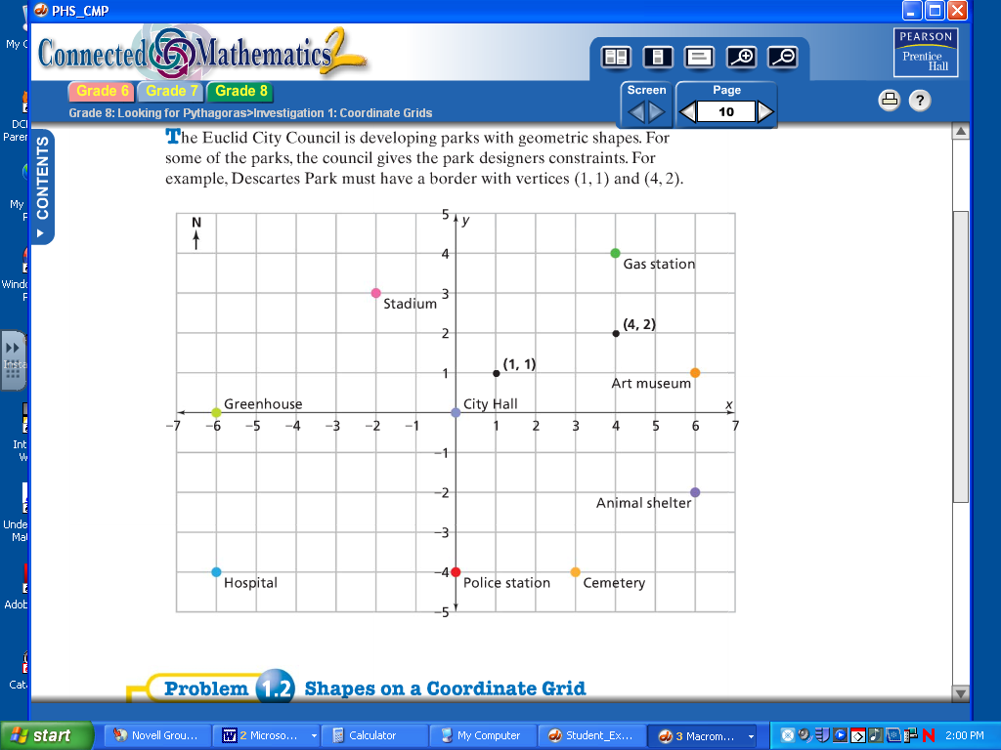

2

12

x

