Name _____________________________________ Hr. ________ Pre-Algebra ROCKS!!!

REVIEW…SIWS (Inv. 1 & 2)

- Find the area of the entire shape
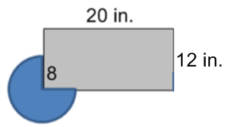

- The Rothschild Aquatic Center is trying to set their summer budget. In order to do so, they make some predictions for the summer. They calculate profit P based on the number of visitors V to the water park. The pool workers also know the number of visitors is based on the probability of rain R occurring. Use the following equations to answer each question. show all work

P = 3.75V − 450 V = 400 − 200R

  - Write an equation for the profit P using the chances of rain R.

  - If the park were expecting to make $1000, what would the probability of rain be?

  - Suppose the probability of rain is 60%. What profit can the water park
expect?

3) Write the equation and find 4) Find the area of the pool below

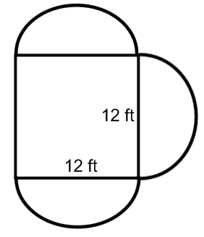
the area of the shaded region.
Use A= πr² and A = bh for help

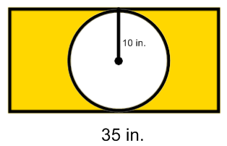

Solve each equation. Show all work!
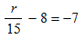
5) 3 - 4x + 6 = 53 6) 3 - (x – 2) = -25 7)

Random answers: 7% 386 P=1050-75R -11

390.72 600 30 312.6 15

